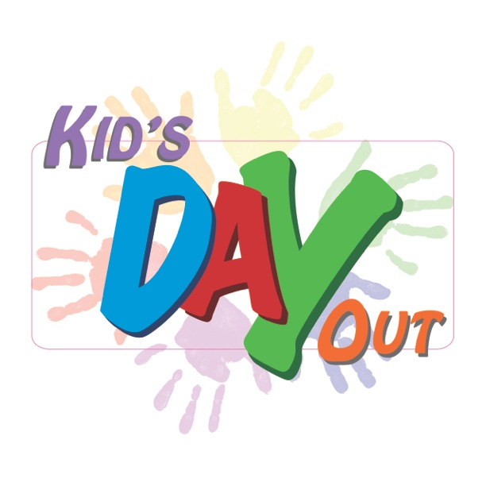
Kids Day Out
Kids Day Out direct line: 972-822-9034
First Irving / 403 South Main Street / Irving, TX. / 75060

Fall 2019/Spring 2020

When: Classes are held two days each week on Monday’s and Friday’s from 9:00 am to 2:45 pm. Late fees will start at 2:50 pm.
Fall/ Spring
TIME ONLY

Who: Children who are 15 months- 5 years by September 1

Start Date: Last week Aug. (Final date published when Irving ISD releases Calendar)

End Date: Mid May 2020(Final date published when Irving ISD releases Calendar)

Enrollment Fee: $120 per child [NON-REFUNDABLE]
$110- For each additional child [NON-REFUNDABLE]

August Tuition: Depending on school start date, possible $90 August tuition.

September to May Tuition: [tuition payments are NON-REFUNDABLE]

One Child 15 months and older:
$195. per month

Two Children 15 months and older:
$365. per month (includes a $25 discount for 2nd sibling)

Three children: Please see the Director.
- Your child’s spot is only reserved when the enrollment fee is paid.

